Topic: SpendWise

Team ID : SWTID-2026-6161
Team Size : 5
Team Leader : V TAMIL SELVAN
Team member : Sivaprakash
Team member : Sujith.R
Team member : VEERAMANI B
Team member : A.yugeshwaran

SpendWise
- INTRODUCTION

SpendWise is a smart personal finance management system designed to help individuals track, manage, and control their daily expenses effectively. In today’s fast-paced world, many people find it difficult to monitor where their money goes, which often leads to overspending and poor financial planning. SpendWise provides a simple and user-friendly platform that allows users to record their income and expenses, categorize spending, and analyze their financial habits.

- PROJECT TITLE

SpendWise – A Simple Backend Learning Project using Node.js,
MongoDB and JWT

- Project Overview
SpendWise is a personal finance management application designed to help users track and manage their daily expenses and income efficiently. The main goal of this project is to improve financial awareness by providing a simple and organized way for individuals to monitor their spending habits.
Key Objectives:

Track Expenses Easily – Help users record and monitor their daily expenses and income in one place.
Improve Financial Awareness – Allow users to understand their spending habits and manage money more responsibly.
Budget Management – Enable users to set budgets and control overspending.
Organize Transactions – Categorize expenses such as food, travel, shopping, bills, etc., for better financial tracking.
Provide Financial Insights – Generate summaries or reports so users can analyze their spending patterns.
Promote Saving Habits – Encourage users to save money by managing expenses effectively.
Target Users

Students – To manage pocket money and track daily spending.
Working Professionals – To monitor salary, bills, and personal expenses.
Families/Households – To manage household budgets and monthly expenses.
Small Business Owners – To keep simple records of daily income and expenses.
Anyone Interested in Personal Finance Management – People who want to control and improve their financial habits.

Project Instruction
SpendWise is a backend-only project built using Node.js and Express.
- Quick Start:
npm init
npm install
npm run dev

- Steps to Create the Project:
- Choose or create a directory for the backend project.
- Open terminal and navigate to that directory.
- Initialize Node.js project using npm init.
- Install required packages: express, mongoose, jsonwebtoken, bcrypt, cors, dotenv.
- Create folders: models, routes, controllers, middleware, config .
- Start the server using npm run dev.
Test APIs using Postman or Thunder Client at http://localhost:5000.

Pre-requisites:

- Software Requirements

Software | Purpose
Node.js | JavaScript runtime for backend
MongoDB | NoSQL database for data storage
npm | Package manager
Git | Version control system
Code Editor | VS Code or similar

- Knowledge Requirements

- JavaScript ES6+
- Node.js and Express.js
- MongoDB and Mongoose
- JWT authentication
- Basic REST API concepts
- Git basics

Project Architecture Image

Technical Architecture

- Backend Architecture (Node.js + Express)

- Controllers: Handle business logic for authentication and CRUD
- Models: Mongoose schemas for User and Transaction
- Routes: API endpoints for auth and CRUD operations
- Middleware: JWT verification and request protection
- Configuration: Database connection and environment variables

- Database Architecture (MongoDB)

- Users Collection:
_id, name, email, password (hashed), createdAt
- Transactions Collection:
_id, userId (FK), title/description, amount/value, createdAt
- Relationship:
Many Transactions belong to One User

ER Diagram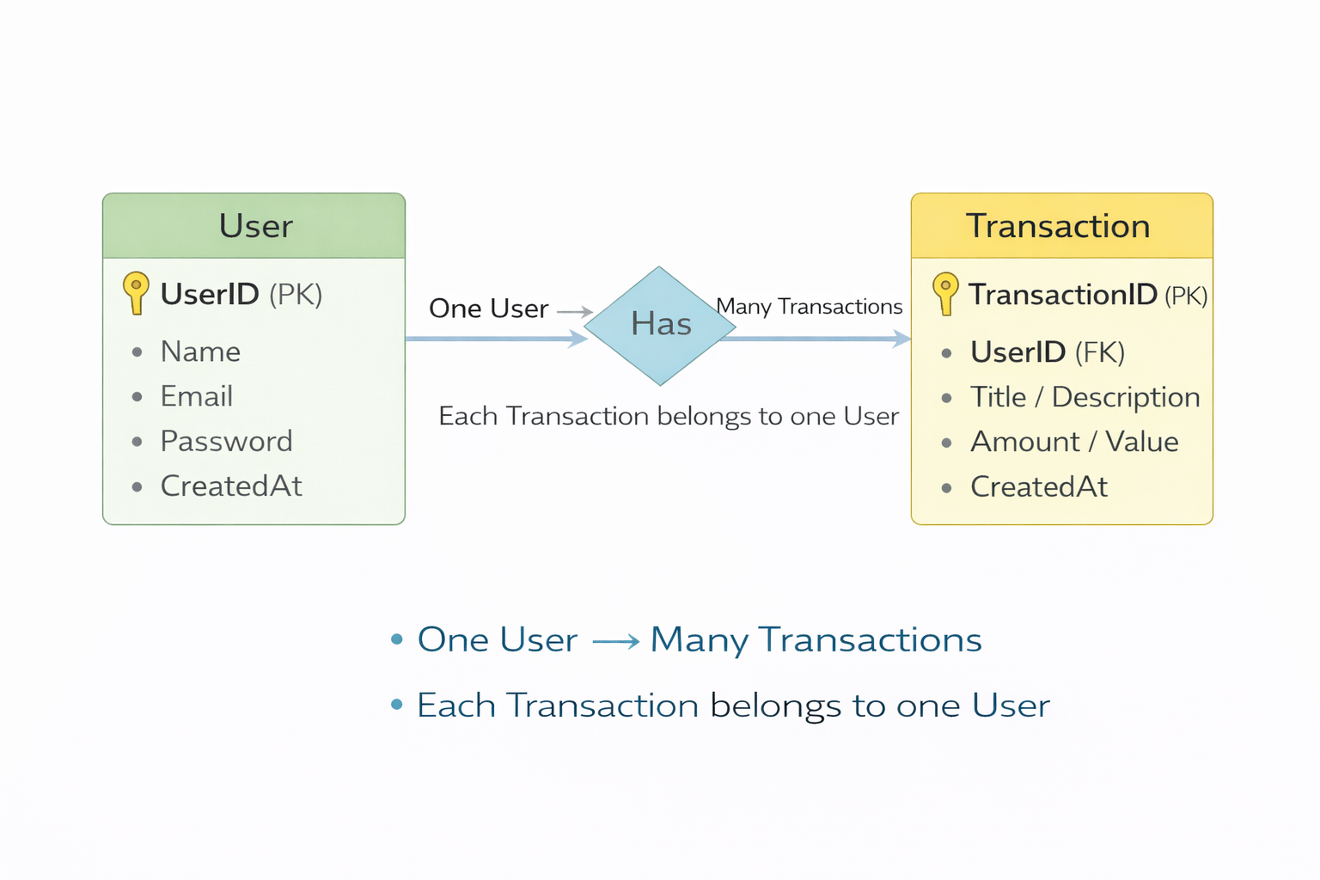S

Features

Feature

Description

User Authentication

JWT-based registration and login

CRUD Operations

Create, Read, Update, Delete transactions

Protected Routes

Secure APIs using JWT middleware

MongoDB Integration

Store and fetch data using Mongoose

Roles and Responsibilities

Student / Developer:
- Write backend code
- Create APIs
- Test APIs using Postman/Thunder Client
- Push code to GitHub

- System (Backend):
- Authenticate users using JWT
- Handle CRUD operations
- Store and fetch data from MongoDB
- Protect private routes

PROJECT SETUP AND CONFIGURATION

Folder Structure
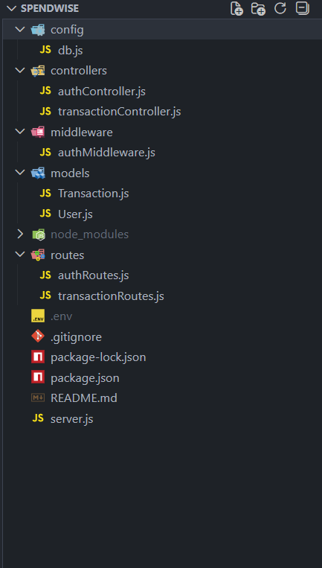

- Project Setup
1. Install required tools:
- Node.js
- MongoDB

2. Create project folders:

- server folders (models, routes, controllers, middleware, config)

3. Install Backend Packages:

- Express
- Mongoose
- Cors
- Jsonwebtoken
- Bcrypt
- Dotenv

Demlink:

https://drive.google.com/file/d/1a8xVtsxe2iiwRL2sG3NNuq2MIljt0NjG/view?usp=drivesdk

